**Creating Tables**

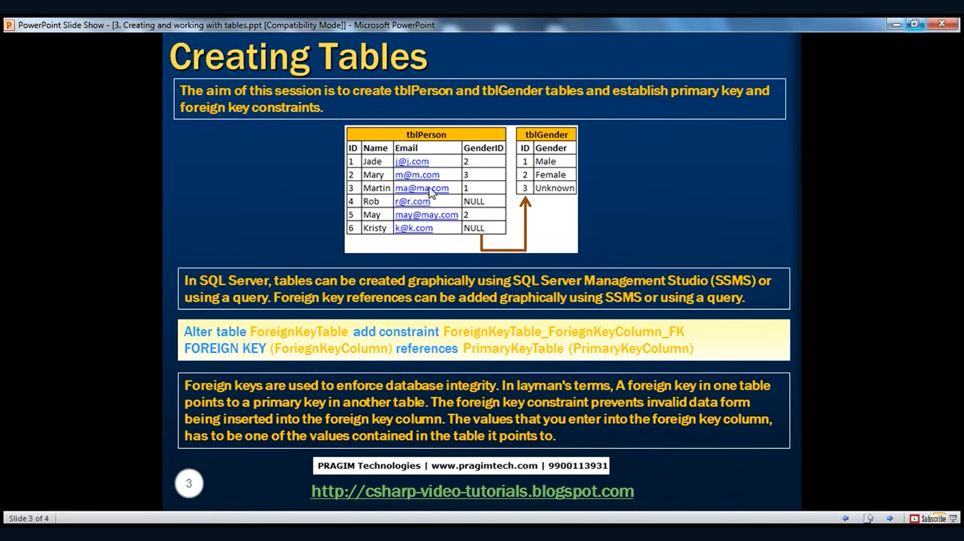

**Creating Table through GUI**

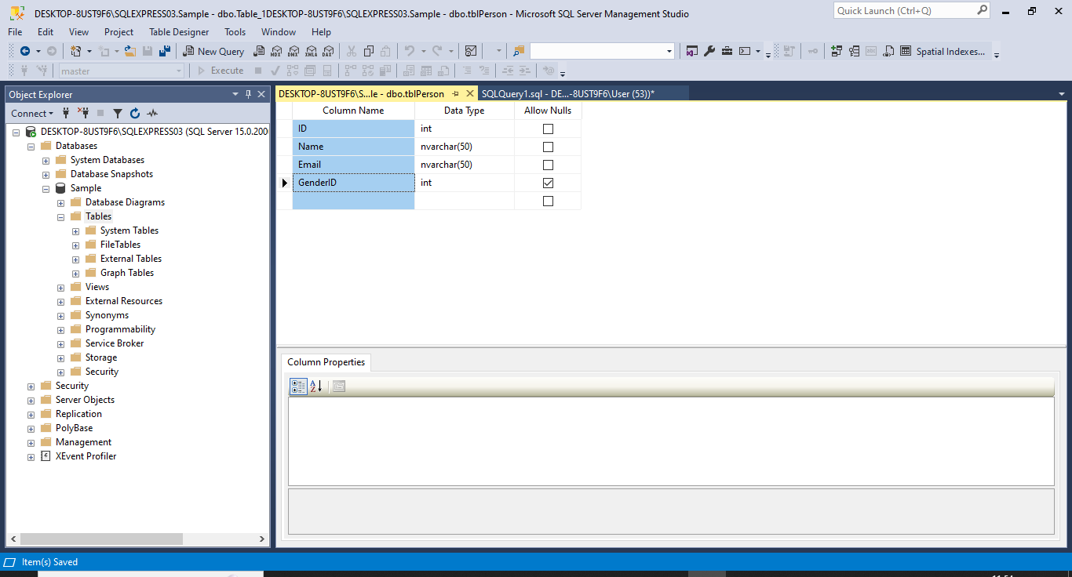

**Creating Table through Query**

Use Sample;

Create Table tblGender(

ID int NOT NULL Primary Key,

Gender nVarchar(50) NOT NULL

)

**Creating Foreign Key**

**Gender Table**

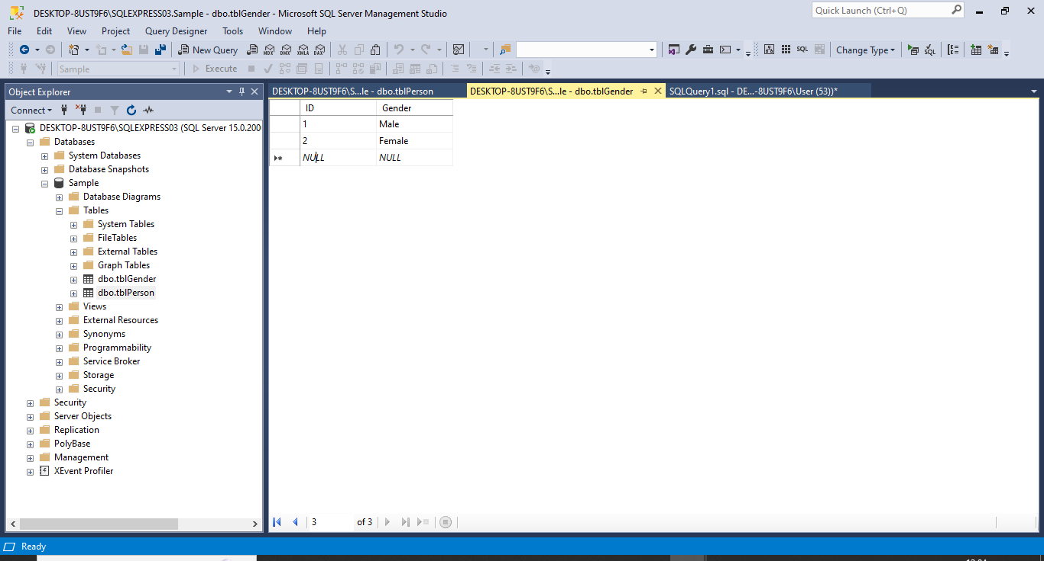

**Person Table**

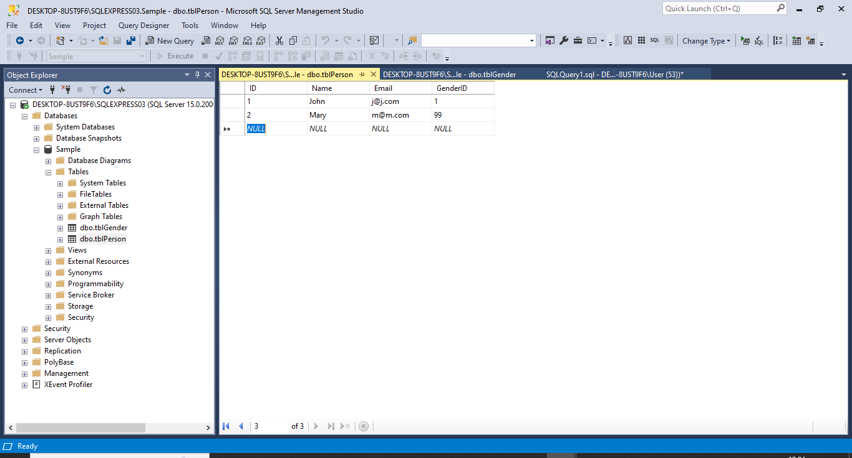

**Adding foreign key through GUI go to table- do right click and click on Design**

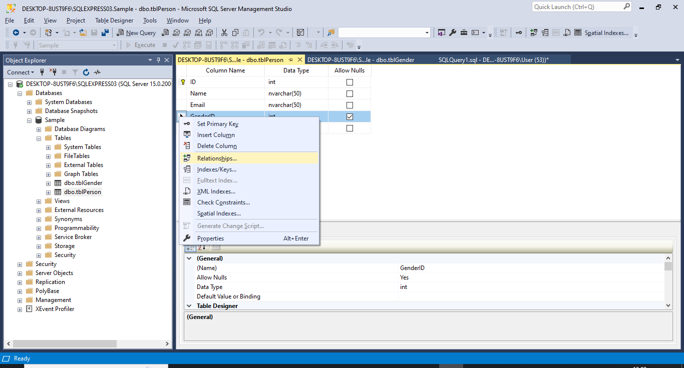

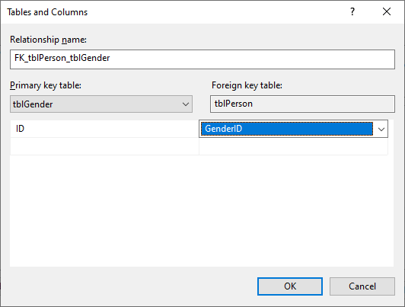

**Using Query**

Alter table tblPerson add constraint tblPerson_GenderID_FK

Foreign Key (GenderID) references tblGender(ID)

**Note – Foreign keys checks the integrity of the data it will not allow to add any invalid values in GenderID column.**

